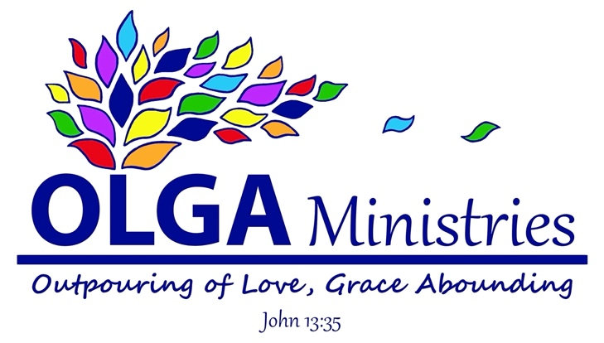

OLGA Ministries 2020 Year End Review

First of all, all of us at OLGA Ministries want to say thank you to each of our wonderful donors who have made this ministry possible! 2020 has been a challenging year in many ways. 2020 has also brought about many possibilities for God to work. The inability to travel, early in the year, pushed us towards forming a non-profit organization to be able to continue carrying out the work we had been doing in Honduras. This non-profit turned into OLGA Ministries! We are so amazed and thankful for all God has been doing through this organization already. We are also amazed by and thankful for you, our donors! God has multiplied your gifts and done amazing things through your giving. We want to take the opportunity to share with you what God has done through OLGA Ministries in 2020 and some of our hopes for 2021.

Since receiving our 501(c)-(3) status with the IRS, on June 12, we have received $21,585.44 in donations! We have spent $21,556.76, with only 3.9% going toward our operating costs, which means about 96% of your donations have been able to go directly to making a difference in the lives of the people we are serving!

I would like to highlight some of the projects we have taken on this year:

- We built a house for a young, single mother of 4. Alba was living, with her children, in a shack, that was literally falling apart. Now she has a nice home with concrete block walls and concrete floors. She was equipped with a water supply and the resources needed to begin her own laundry business, so that she will be able to provide for herself and her children, no longer needing to rely on charity.

- We have been able to provide groceries to 11 families living in the Reniel Funez community, just outside Tegucigalpa, Honduras. COVID-19 restrictions hit Hondurans very hard. Many have been out of work for most of the year, making it very hard to provide food for their families. We are so thankful to have been able to help in this way.

- We have provided groceries and medical resources to Centro Integral Fe, Esperanza y Amor Orphanage just outside Tegucigalpa, Honduras. We have been partnered with this orphanage since January 2018. We have fallen in love with the 27 girls who live there, along with Kristian (the home mother), Olga and Isaac (the founders and directors), their children Vivian and Randy, and Randy’s wife Suany.

- We replaced the roof on one of the orphanage’s dormitories. They realized the roof was caving in. The older wooden rafters were replaced with metal and the pitch of the roof was increased to prevent further issues.

- We provided relief to victims of hurricanes Eta and Iota. The coastal regions of Honduras were hit hard by both of these hurricanes. This was devastating to the people affected, who were already struggling due to the restrictions imposed by COVID-19. We had direct knowledge of some of these people living in San Pedro Sula, who experienced severe flooding. We were able to replace many of their lost possessions as well as provide groceries and money for clean water and electricity.

- Finally, we provided Christmas gifts to the girls at Centro Integral Fe, Esperanza y Amor Orphanage and the children belonging to the 11 families we supported with groceries throughout the year, for a total of 55 children! Along with gifts for the children, we were able to provide Christmas groceries to each of the families as well.

We are amazed as we look back at all God has allowed us to accomplish in 2020. We pray that God will continue to use OLGA Ministries in 2021 to make an impact for His kingdom. Let me share with you some of our aspirations for 2021:

- Firstly, we want to continue being a support for any unmet needs Centro Integral Fe, Esperanza y Amor Orphanage may have.

- We want to be able to provide crisis relief to anyone who needs it through groceries or other needs as they arise, whether due to natural disaster or lack of income for whatever reason.

- We have been made aware of a family in the Reniel Funez neighborhood, just outside Tegucigalpa, Honduras, who is living homeless at this time. We pray that God will provide the funds to build them a home. They own property in the neighborhood, but are unable to afford to build any type of structure on it. We also pray that we will be able to provide this family with a way to be self-sufficient in the future.

- We are praying for the opportunity to provide Christmas gifts to every child in the Reniel Funez community. This would be approximately, just over 700 children. Along with a gift, we long to share Jesus’ love with the entire community.

- We are wanting to find more ways to reach out to the Reniel Funez community, surrounding the orphanage, to build friendships and trust. We pray we are able to make a huge impact for the kingdom of God in the lives of these people, many of whom are living in extreme poverty.

Thanks again for your support! On the next page you will find a breakdown of our finances from 2020. If you haven’t visited our website feel free to check it out at OLGAMinistries.org. We try to update our News page as new projects arise. You can also follow us on our Facebook or Instagram page.

Finally, please help us to pray traveling restrictions lift. We miss our Honduran family. Although we long to return, we are so thankful that we are able to continue this ministry through OLGA Ministries, even while we cannot physically be in Honduras. A special thank you to Vivian, Olga and Isaac for making this possible!

Jessica Tharp
Executive Director
OLGA Ministries

